**Stool Collection and Shipping Instructions:**

**Important note about shipping:** Samples should be collected and packaged and a FedEx pickup should be scheduled for **every other** **Monday** according to the Sample Collections Calendar your research coordinator has given you. Please contact your research coordinator if you have any questions or anticipate a delay in sample receipt.

Note: If a sample is scheduled for collection on a holiday, please delay the collection until Tuesday.

You will be given kits in batches according to the following schedule:

* At the screening colonoscopy, you will be given 1 stool collection kit to be used for collection 1.
* At the baseline visit (month 0), you will be given the remaining 5 stool collections kits to be used for collections 2-6.

**Note:** If you are a healthy control and opt to complete the screening and baseline visits on the same day, you will be given 6 kits at once.

* At your *month 3 visit you will be given 6 new collection kits to be used for collections 7-12.
* At your month 6 visit you will be given 6 new collection kits to be used for collections 13-18.
* At your *month 9 visit you will be given 6 new collection kits to be used for collections 19-24.

*Healthy controls will be mailed 6 kits by their research coordinator at month 3 and again at month 9.

**Each kit will contain the following items:** (enough supplies for 6 return shipments)

|  |  |  |  |
| --- | --- | --- | --- |
| □ | x 6 |  | Stool collection tube with ethanol (red dot) |
| □ | x 6 |  | Stool collection tube w/o preservative (blue dot) |
| □ | X 6 |  | Biohazard bag with date/time label |
| □ | X 6 |  | Small (6”x6”) easy fold *return* shipper |
| □ | x 6 |  | Fed-Ex clinical pak |
| □ | X 6 |  | FedEx preprinted return shipping label |
| □ | X 6 |  | Stool collection hat + collection cup/lid |
| □ | X 6 |  | Pair of gloves |
| □ | X 6 |  | Questionnaire packet (Includes Activity Index & Dietary Recall) |

*\*If you are missing any items please let the study team know as soon as possible!*

|  |  |
| --- | --- |
|  | **STEP 1**. Raise the toilet seat. Place the stool collection frame on the back of the toilet bowl. All four corners of the collection frame should be supported by the toilet bowl. Place collection bowl in the frame. |
|  | **STEP 2**. Place the toilet seat down. Do **not** urinate into the collection container. Deposit your stool directly into the collection container.  **STEP 3**. After collecting your sample, remove the container from the frame. |
|  | **STEP 4.** Unscrew the tube containing ethanol preservative (red dot) and use the scoop on the lid to transport **exactly one full scoop** from the white collection bowl into the tube. DO NOT fill the tube completely. Screw the cap back on tightly.  *Please take care not to spill any preservative*.  If you get any preservative (ethanol) on your skin, please wash with soap and water.  Red dot= Includes ethanol preservative |
|  | **STEP 6.** Unscrew the tube without preservative (blue dot) and use the scoop on the lid to transport **one full scoop** from the white collection bowl into the tube. DO NOT fill the tube completely. Screw the cap back on tightly.  *This tube does NOT contain preservative. Please do not pour preservative from another tube into this tube.*  Blue dot= no preservative |

|  |  |
| --- | --- |
|  | **STEP 7.** Fill out the date and time of collection on the front of the small plastic bag. Then place all 3 tubes inside and seal the bag completely. |
|  | **STEP 8.** Fold the corresponding dietary questionnaire in half then fold it in half again and place it in the front pouch of the biohazard specimen bag.  **STEP 9.** Place this entire assembled kit inside the easy fold mailer. |
|  | **STEP 10.** Place the easy fold mailer inside the plastic FedEx Clinical Pak. Affix the preprinted FedEx express shipping label to the outside of the Clinical Pak.  **STEP 11.** Follow the instructions on the next page to schedule a FedEx pickup. |

**FedEx Shipping Instructions:**

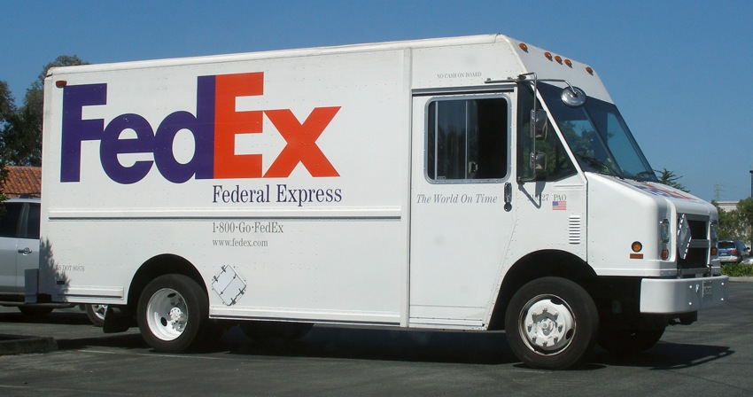

**Biological Samples**

1) Call **1-800-GO-FEDEX** (1-800-463-3339) to schedule a home pickup.

2) The automated system will answer and give you several options. Following the options verbally state “schedule a pick up”.

3) The system will ask you to enter or verbalize your 9 digit account number. The account number is **XXXX-XXXX-X**

4) When asked if you want an express or ground delivery, please state “express”.

5) Depending on what time of day you call, the system may ask if you the package is ready for pick up now. Please respond “NO” if it is to be picked up the next day. If it needs to be picked up that day, please respond “YES”.

6) You will be asked for your zip code followed by the number of packages, and if any of them are over 150 pounds.

7) You will be required to provide the address where the package will be picked up.

8) The system will then confirm the pick up time and location. After confirming the pick up is scheduled properly, the system will hang up.

9) At any time during the call you may be directed to a customer service representative to confirm the details of your pick up.

Samples can also be dropped off at a **staffed** FedEx location (not a drop box), if preferred.

Please remember to only schedule pickups on \***Mondays**. These samples should be **mailed within 24 hours of collection**. Please note that samples should be mailed ambient (room temperature).

*or Tuesday if Monday is a holiday

**If you have any questions about the stool collection procedures, please do not hesitate to contact your research coordinator at  
(617) 726-0698 or email ibdmdb@broadinstitute.org**

**Thank you for your participation in this study!**