Clinical Research Coordinator SOPs: Stool kit assembly
Last updated: October 8, 13

This SOP outlines the purchasing of supplies and assembly of stool collection kits

Materials for ONE fecal collection kit:

- (2) Sarstedt stool collection tube with scoop
- (1) Stool collection tube label w/ red dot indicating ethanol
- (1) Stool collection tube label w/ blue dot indicating no preservative
- (1) 5 mL of ethanol (EtOH)
- (1) Stool collection date/time label
- (1) Biohazard bag
- (1) Small (6”x6”) easy fold return shipper
- (1) Large (14”x14”) easy fold outgoing shipper
- (1) Printed Dietary Recall And Activity Index
- (1) Category 3 in exempted quantity label
- (1) Fed-Ex clinical pak
- (1) FedEx shipping label
- (1) Stool collection hat + collection cup/lid
- (1) Pair of gloves

- At the screening colonoscopy, subjects will be given 1 stool collection kit to be used for collection 1.
- At the baseline visit, subjects will be given 5 stool collection kits to be used for collections 2-6. Healthy controls who prefer to complete screening and baseline visits on the same day should be given 6 kits.
- At the baseline visit, subjects will be given a pre-completed Stool Collection Calendar.
- At each visit, subjects will be given a copy of the Instructions Stool document.
- At the *month 3 visit, subjects will be given 6 new collection kits to be used for collections 7-12.
- At the month 6 visit, subjects will be given 6 new collection kits to be used for collections 13-18.
- At the *month 9 visit, subjects will be given 6 new collection kits to be used for collections 19-24.

*Healthy controls will be mailed 6 stool collection kits by their research coordinator at month 3 and again at month 9.

Instructions for Kit Assembly: Coordinator should plan to assemble approx. 20 kits per week

- Fill 1 of the stool collection tubes (A) with 5mL of ethanol (D). Place 1 label with a red dot (B) on the tube.
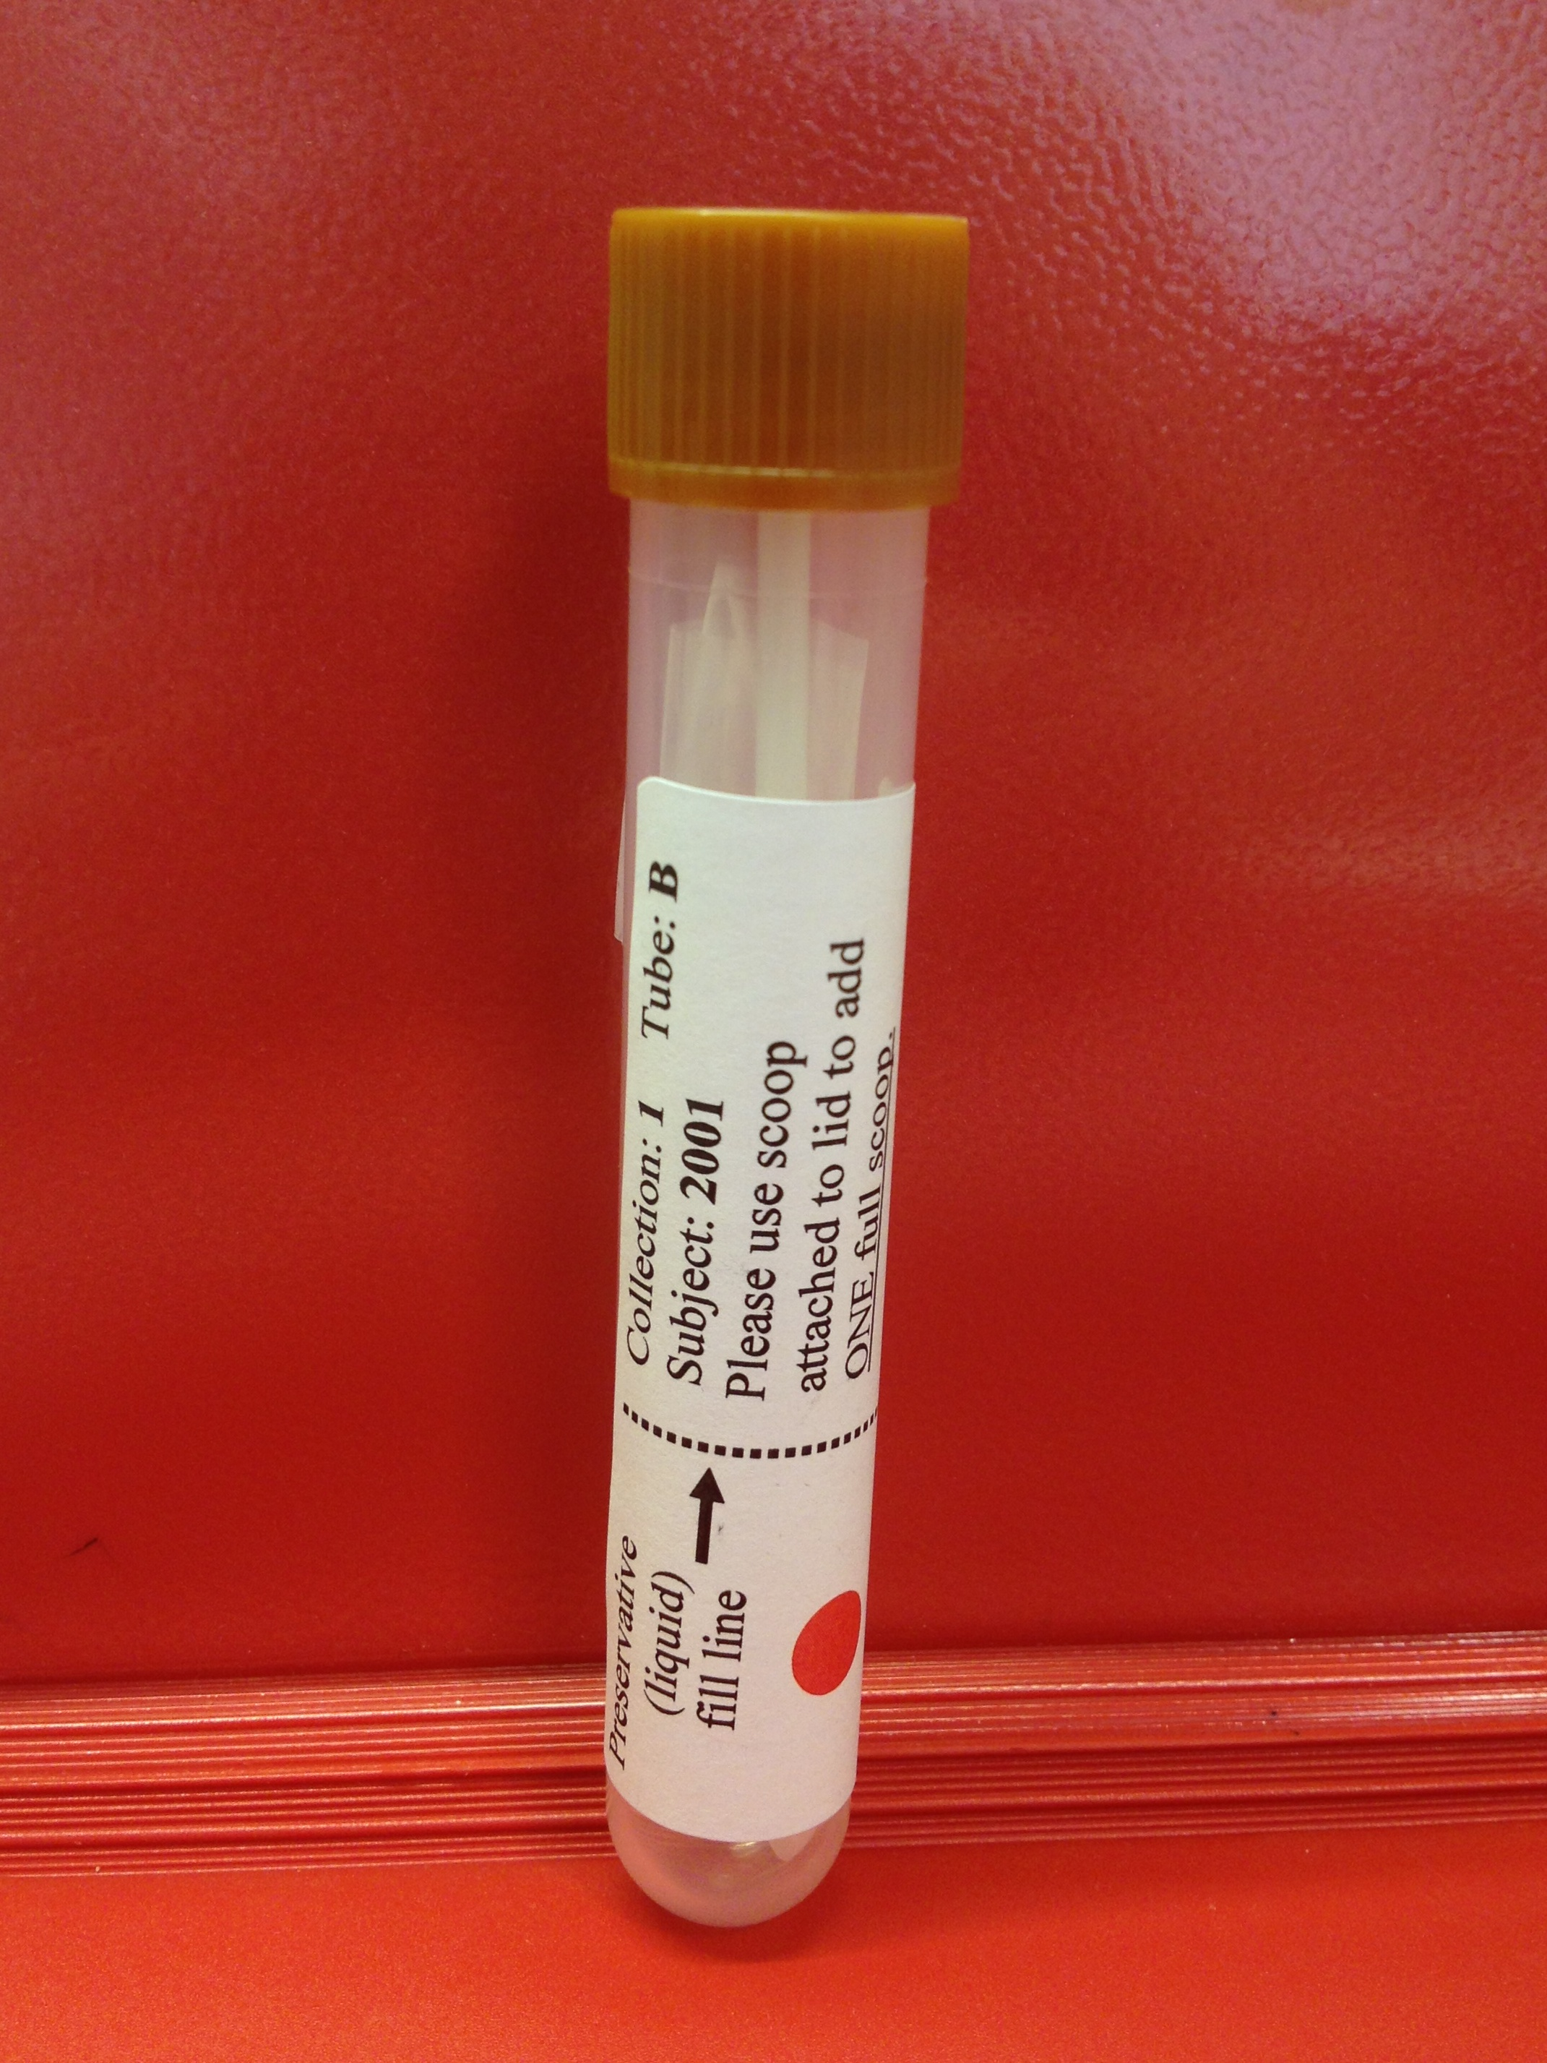

- Place 1 label with blue dot (C) on the other stool collection tube (A). This tube should contain no preservative.
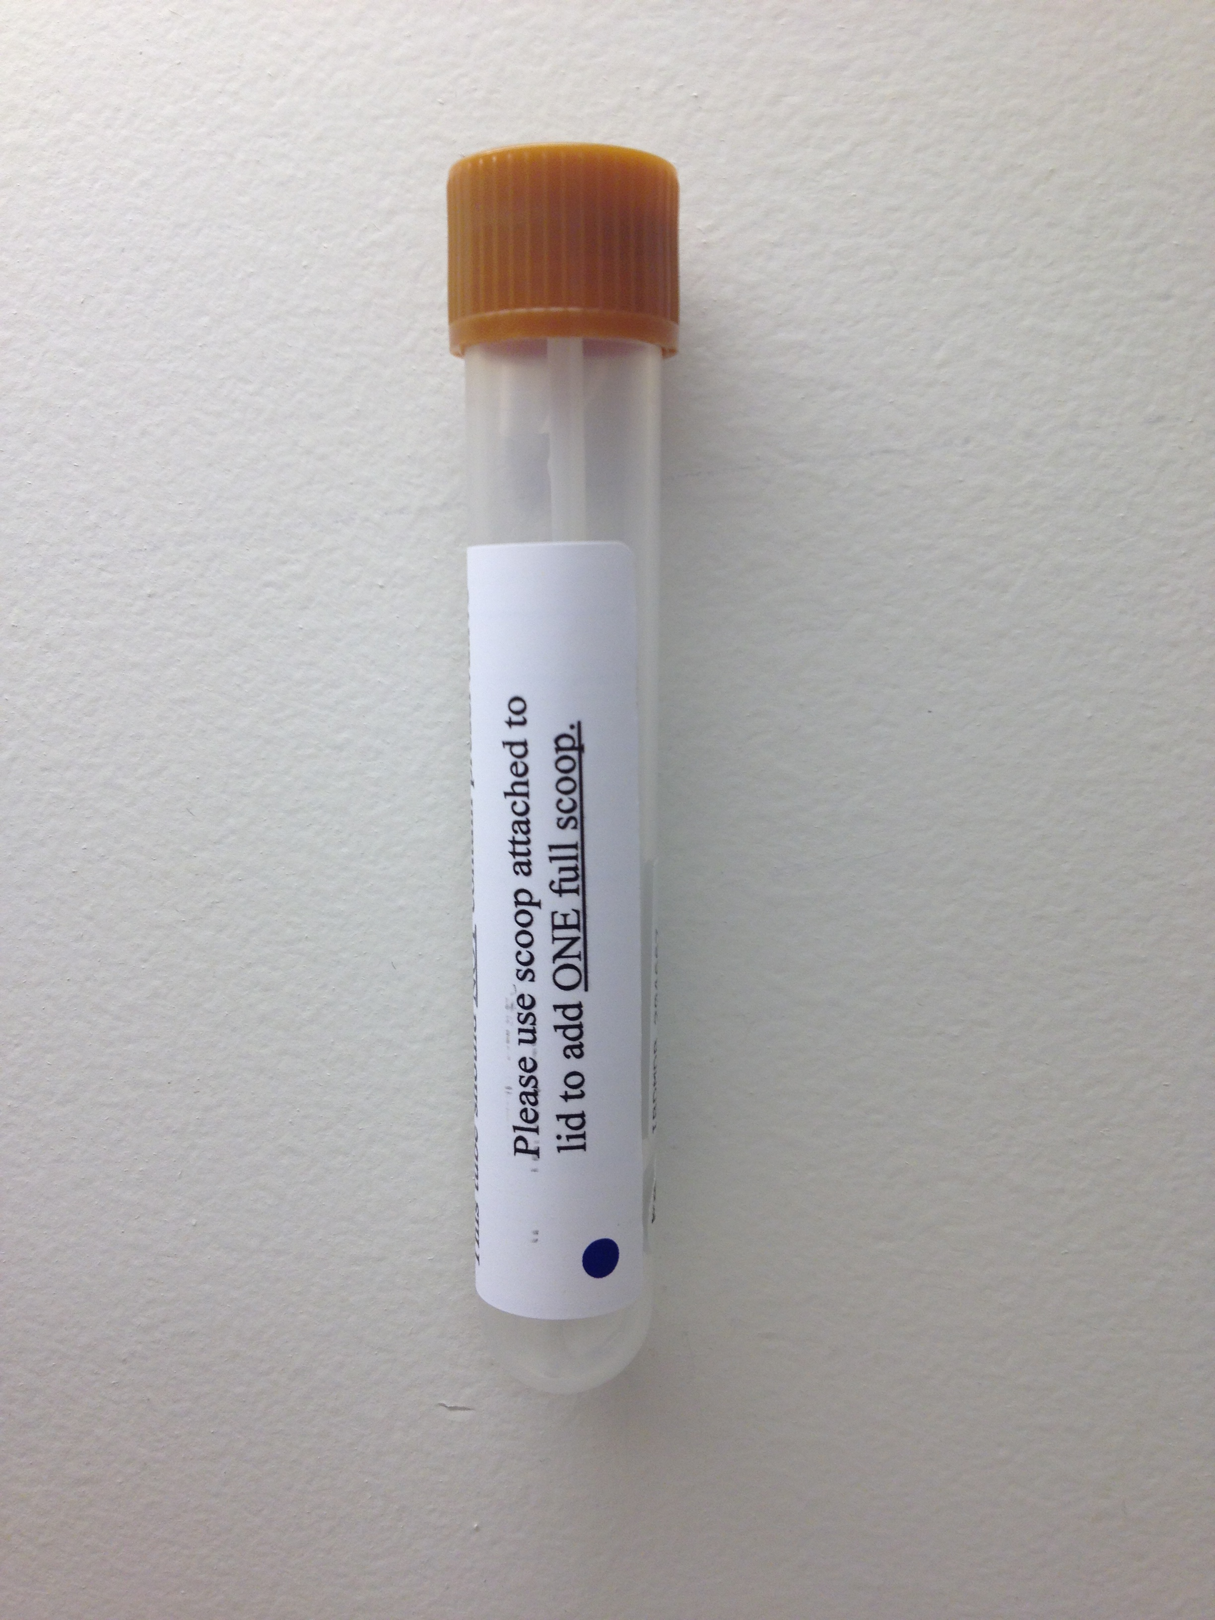

- Sample IDs with barcode labels will be provided to each site and should be adhered to the tubes.

- Place stool collection date/time label (E) on front of biohazard bag (F).

- Place both labeled stool collection tubes inside biohazard bag.
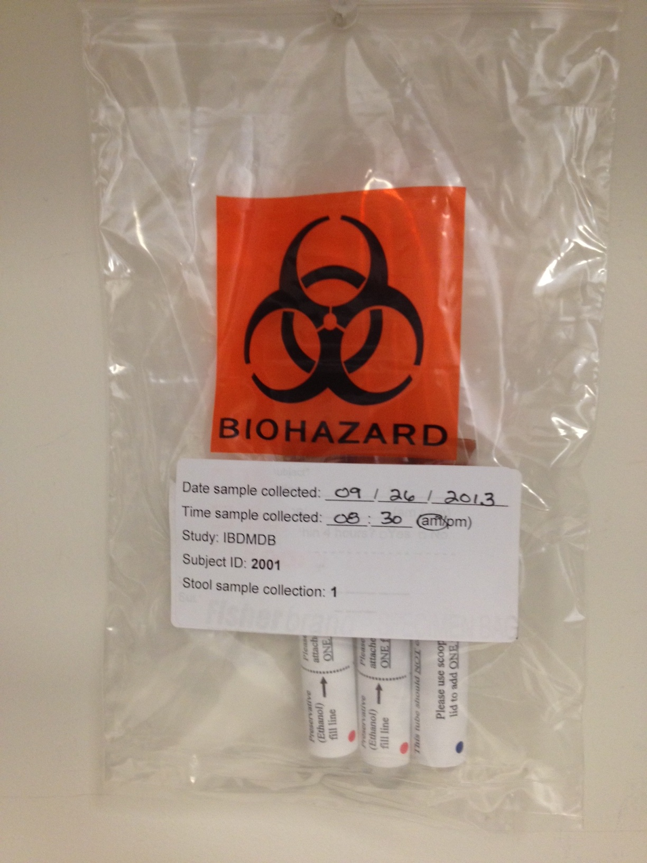

- Assemble small easy fold return shipper (G) and large easy fold outgoing shipper (H).
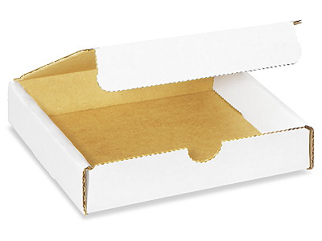 (small= return shipper) + 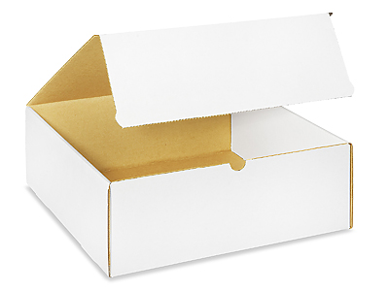(large= outbound)

- Fold Dietary Recall And Activity Index questionnaire (I) in half then in half again and place in front pocket of biohazard bag.

- Place biohazard bag (with included tubes & questionnaire) on top of 1 FedEx preprinted return shipping label and close the return shipper (G).

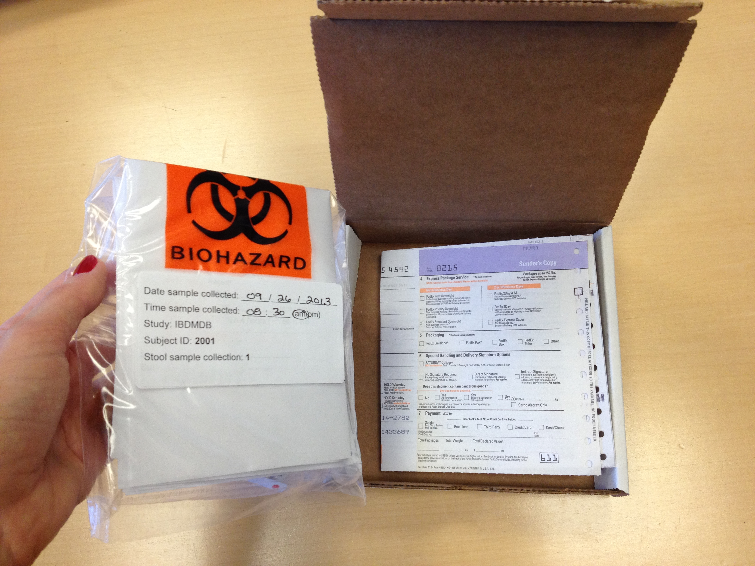

- Number the outside of the return Shippers (Ex: Collection #1-6 OR Collection #7-13) according to the label on the front of the biohazard bag.

- Fill in *shippers address and “3” on category 3 in exempted quantity label (J) and place label on outside of Fed-Ex clinical pak (K).

* Write a large “3” on this label along with your name and office address with a black permanent marker.

 + 
3 John Doe, CRC Lab address

11. Repeat steps 1-10 six times as subjects will need enough supplies to last 3 months or 6 collections.

12. Place the following supplies inside the large easy fold outgoing shipper (H) as follows:

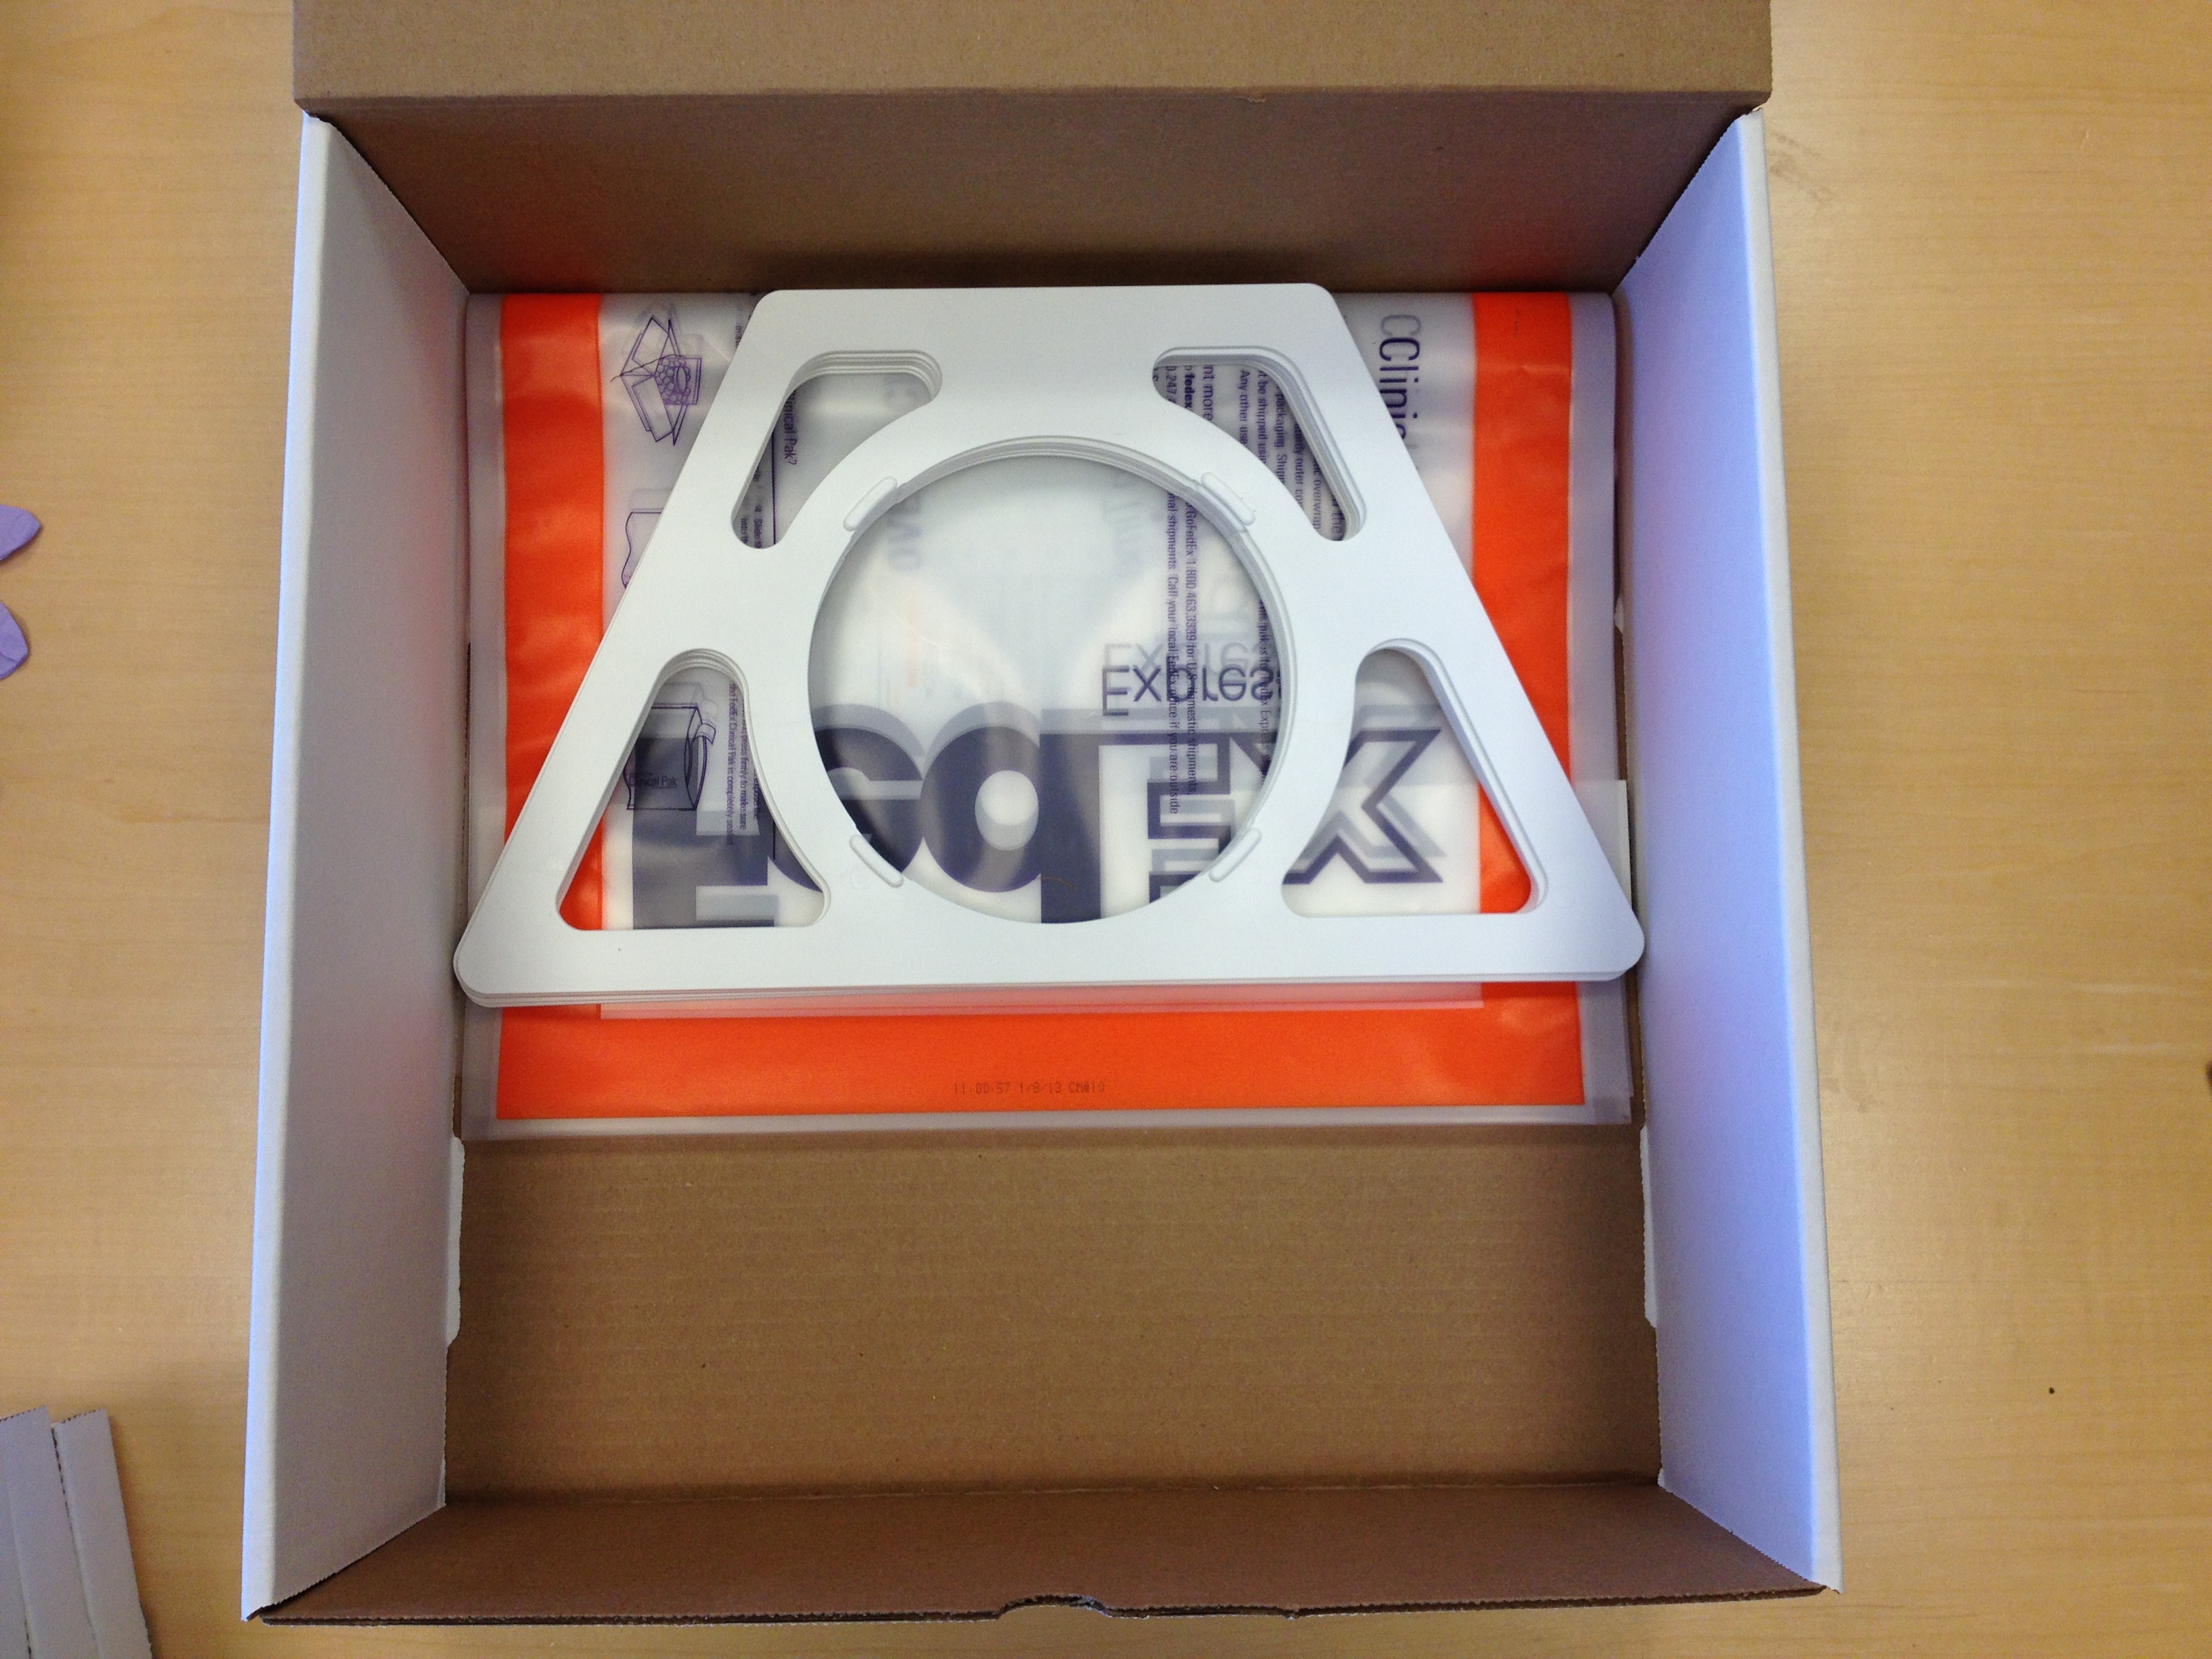 (bottom layer) -> 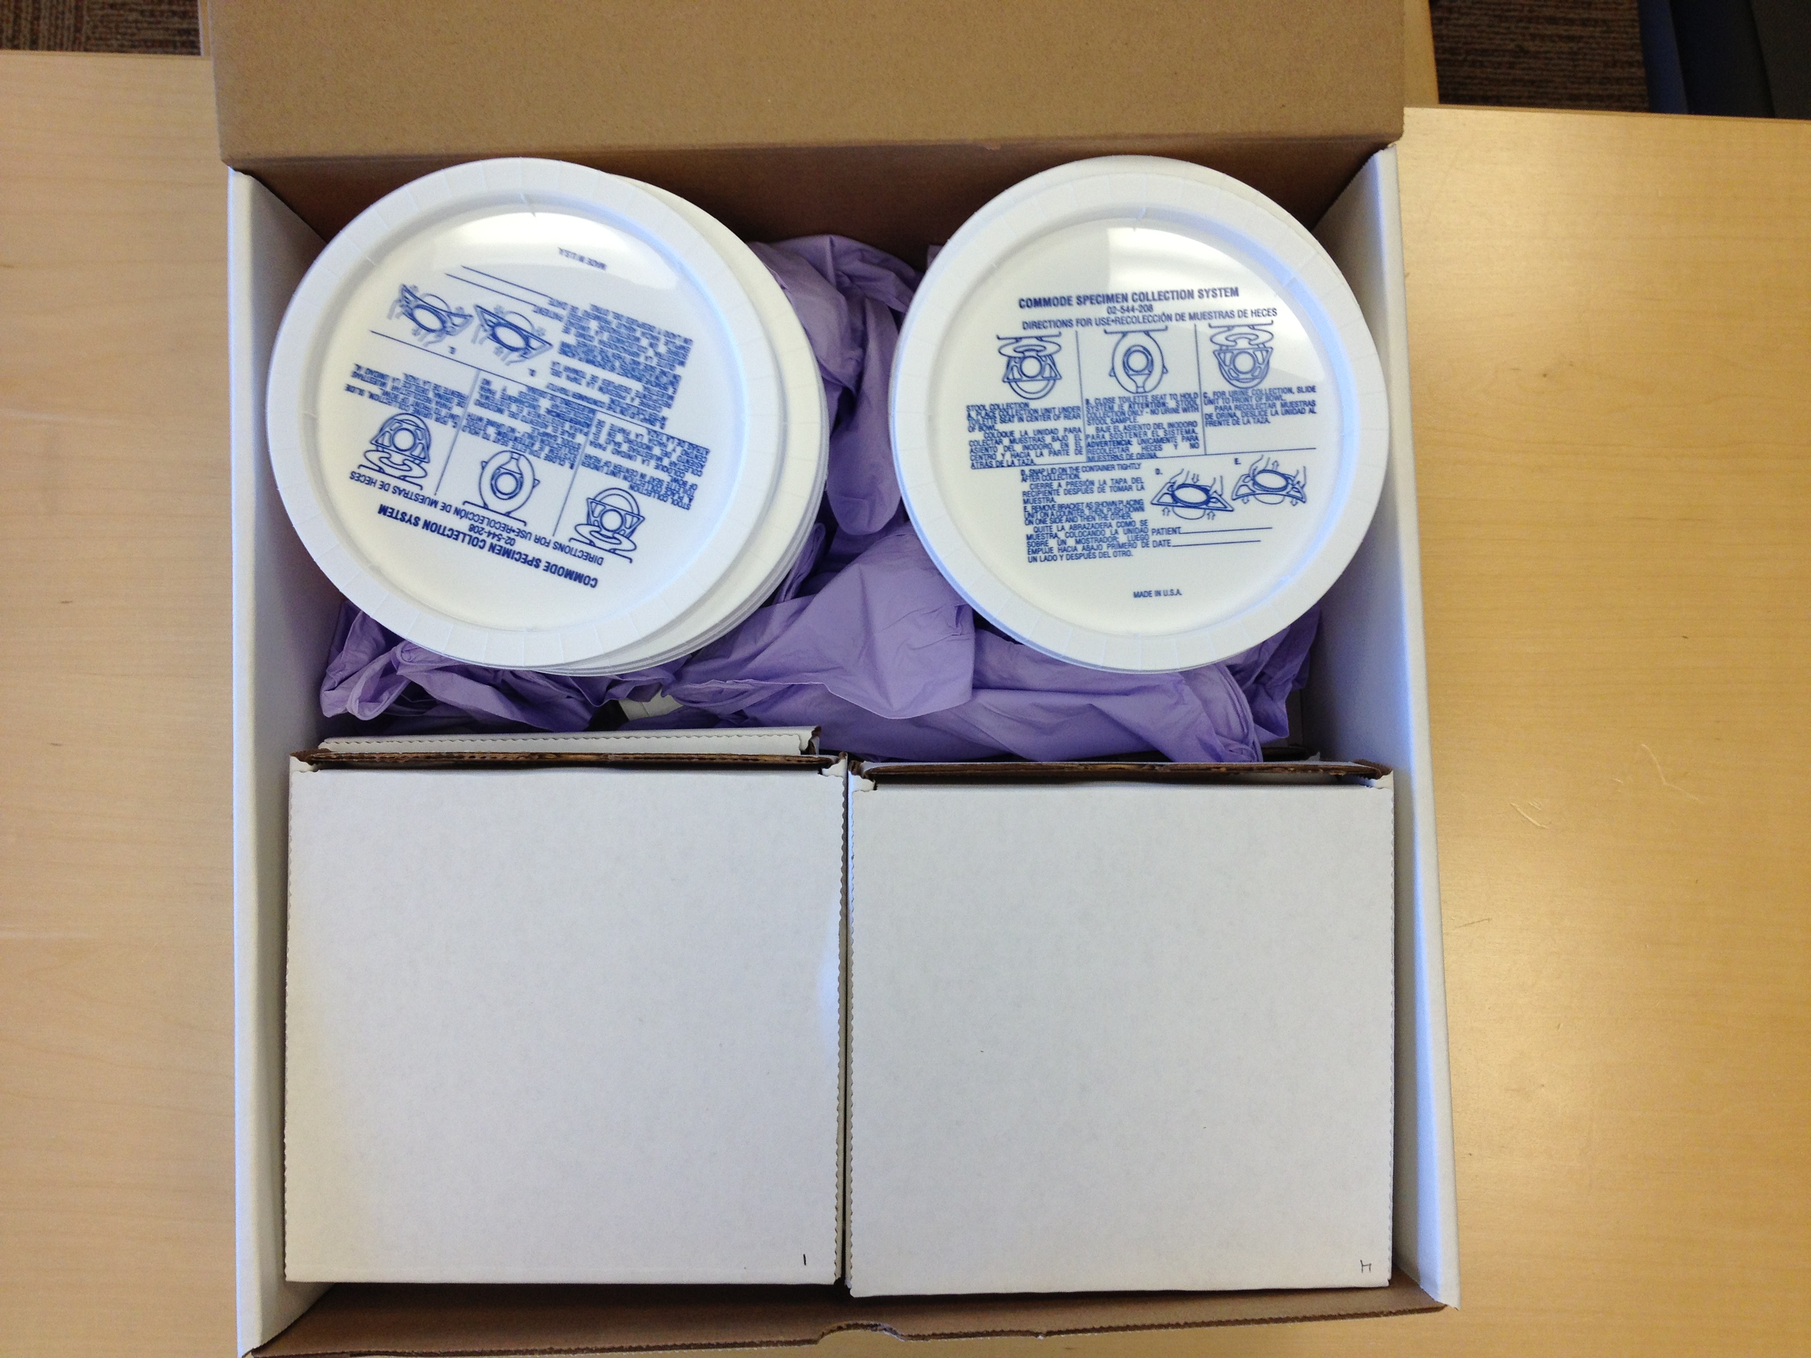 (upper layer)

- All six Fed-Ex clinical paks (with attached category 3 exempted quantity labels)
- All 6 stool collection hats
- All six return shippers (G) (which now include questionnaires, biohazard bags, and stool collection tubes) stacked side by side in 2 columns of 3 each.
- All six sets of stool collection collection cup + lid. (note: Stack 3 collections cups inside each other and then rest 3 lids on top of the stack. Repeat for the remaining 3 cups/ lids)
- All six pairs of gloves can be placed through the remaining empty space to keep contents from shifting.

13. Close outgoing shipper (H) and either mail to patient or give to patient at their next visit to take home with them. If mailing to subject, be sure to use shipping tape to seal the box completely.

 |  |  | Vendor | Catalog Number | Description | UOM |  | Price
A |  |  | Sarstedt | 80.623 | Faeces container w/ screw cap, sterile (500 tubes)  www.sarstedt.com | BX | 132.80
B,C | 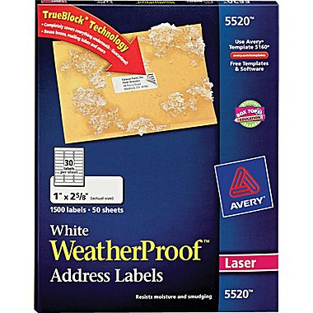 |  | Staples | 440728 | Avery 5520 White WeatherProof Address Labels 1,500/Box  www.staples.com | BX | 54.49
D | 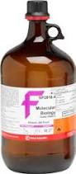 |  | Fisher | BP28184 | Fisher Scientific: Molecular Biology Grade Ethnol  www.Fishersci.com | EA | 191.32
E | 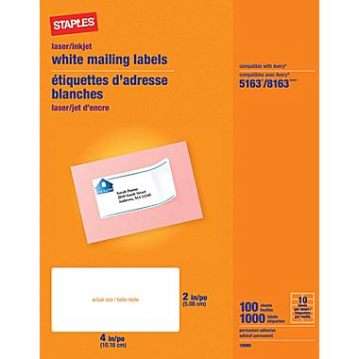 |  | Staples | 479877 | Staples White Inkjet/Laser Shipping Labels 1,000/Box  www.Staples.com | BX | 25.99
F |  |  | Fisher | 0180003 | Fisher Scientific: Biohazard Bag 6X9 (case of 1000= $102)  www.fishersci.com | CS | 102.25
G |  |  | Uline Inc | S-16642 | 6 x 6 x 1 1/4" White Literature Mailers (return)  www.uline.com | EA | 0.38
H |  |  | Uline Inc | S-16944 | 14 x 14 x 5" White Literature Mailers (outbound)  www.uline.com | EA | 1.88
J |  |  | Labelmaster | L350R | Dangerous Goods in Excepted Quantities Label  www.labelmaster.com | RL | 30.10
K |  |  | FedEX | NA | Clinical Paks  1-8oo-Go-FedEx | - | FREE
L | 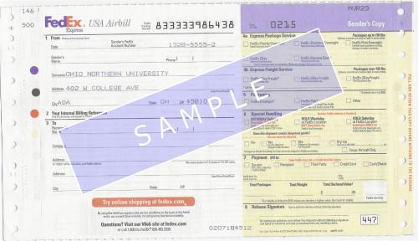 |  | FedEX | NA | Preprinted shipping labels  1-8oo-Go-FedEx | - | FREE
M | 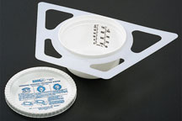 |  | Fisher | 02544208 | Fisher Scientific: SPECIMEN COLLECTION SYST 60/CS  www.fishersci.com | CS | 115.13
 | 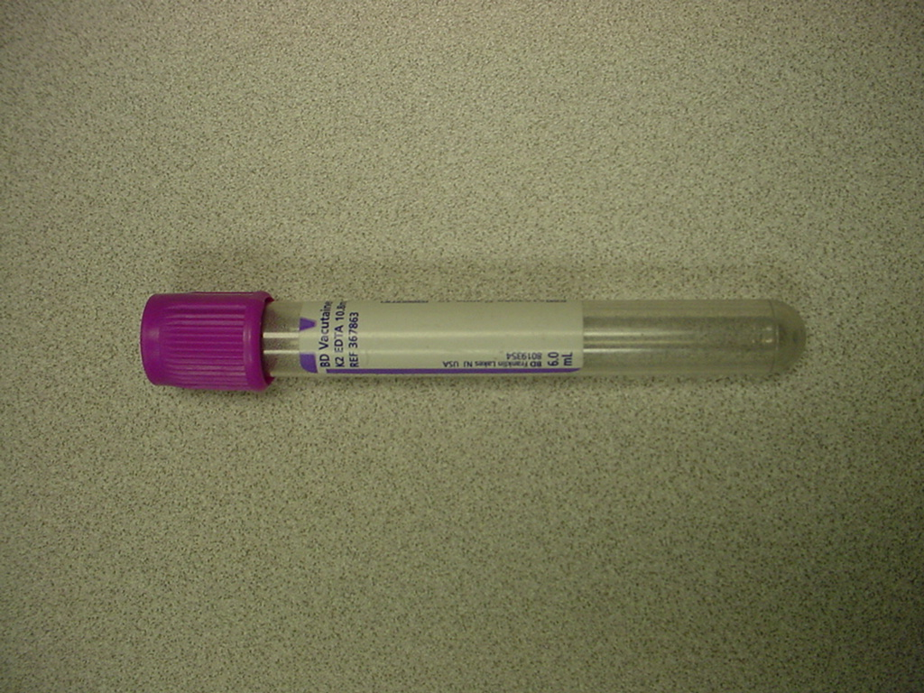 |  | Vendor: Owens&Minor  MFG: Becton Dickinson | *MFG#: 366643 | Blood Vacutainer EDTA Tube (100 tubes) 10mL.  www.catalog.bd.com | BX | 7.21
 | 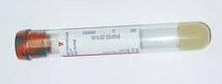 |  | Vendor: Owens&Minor  MFG: Becton Dickinson | *MFG#: 367988 | SST Tube 8.5 PLBL RD/GR BX/100EA ($17 per 100 tubes)  www.catalog.bd.com | EA | 0.16
 | 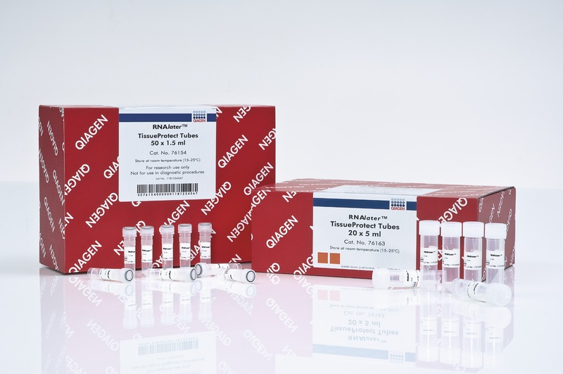 |  | Qiagen | *76154 | RNAlater TissueProtect Tubes 50 X 1.5 M  www.qiagen.com | ST | 233.70
 | 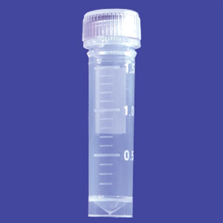 |  | USA Scientific | *1420-9700 | 2mL Tube Bag /500EA  www.usascientific.com | BG | 47.50
 |  |  | Fisher | *G33500 | Fisher Scientific: Glycerol Certified ACS 500ML  www.fishersci.com | EA | 23.86
*supplies are for blood and/or biopsy collection and should not be included in stool collection kits.

